**Name: Muhammad Usama**

**Registration number: SP20-BSE-061**

**Subject: Object Oriented Software Engineering**

**Usecase diagram:**

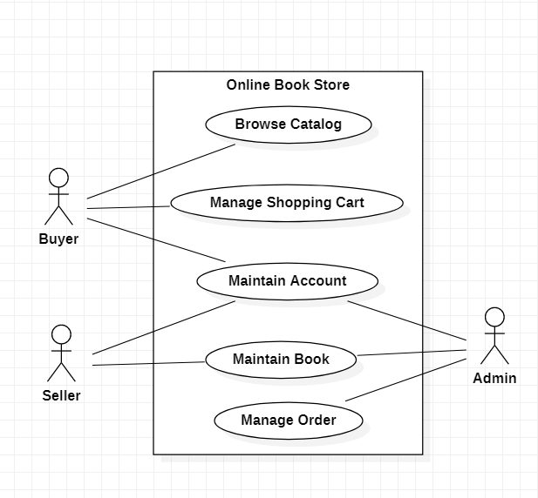

**My Use Case Diagram ,which is assigned to me :**

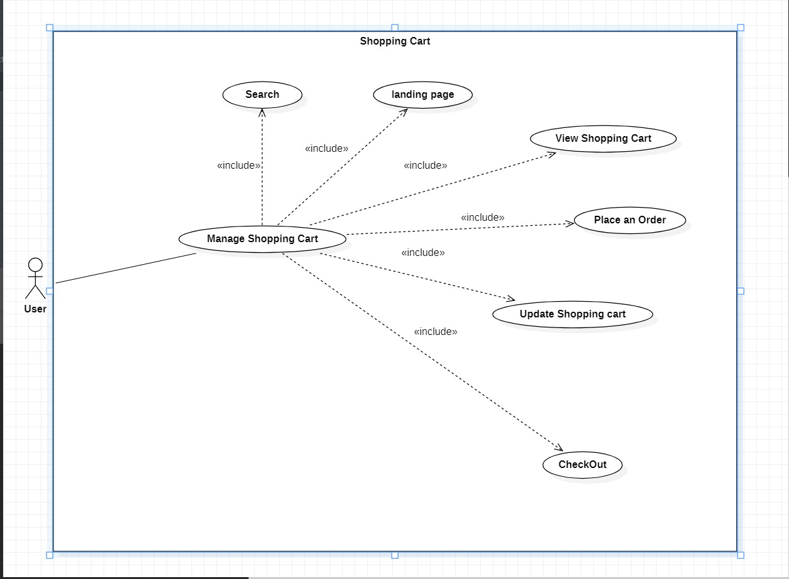

**Brief Case:**

Shopping Cart The user can manage a shopping cart which will include all the books he selected. The user can edit, delete and update his shopping cart. A final shopping cart summary is displayed which includes all the items the user selected and the final total cost.

**Manage Shopping Cart 1)**

**Place an order**

**• Purpose:** If the user wants to purchase a book then he can place an order by selecting the add to shopping cart button and entering the quantity required under the book description.

• **Actor:** User

**• Input:** The user will enter the quantity required and click the add to shopping cart button. • Output: The order will be added to the user’s shopping cart**.**

**2) Update Shopping Cart** **• Purpose**: If the user wants to change the quantity of a book or change a book then he can update his shopping cart.

**• Actor**: User

**• Input:** The user will click the details button in the shopping cart summary to edit and update his order details..

**• Output:** The updated order details are reflected in the shopping cart summary**.**

**3) View Shopping Cart**

**• Purpose:** If the user wants to view the items he added to the shopping cart then he can click the shopping cart link at the top of the page.

**• Actor:** User

**• Input:** The user will click the shopping cart link at the top of every page.

**• Output:** The user’s shopping cart summary will be displayed in the form of a tabular format with all the books and their quantity. A total cost of all the items is also displayed at the bottom.

**Fully Dressed Use Case:**

|  |  |
| --- | --- |
| Name | Manage shopping cart |
| Scope | Online book shopping |
| Level | use case |
| Primary Actor | Buyer |
| Stakeholders and Interests | Buyer: want to place an order.  Seller: provide the order to buyers.  Admin: Manage accounts and other details of users. |
| Preconditions | The buyer will place an order and will add it to the cart and when he wants to buy it admin will pass it to the seller, so he can provide the buyer his books. |
| Postconditions | After buyer place an order the admin will make sure to review provided details by buyer and will notify seller. |
| Main Success Scenario | Buyer will add a book in the cart and admin system will chck if its available or not |
| Extensions | If the provided details are correct, the deal will continue or else order will be cancelled. |
| Special Requirements | Security, Reliability, Data Integrity, Availability. |
| Variations in Technology and Data | step number: possible change in technology or data format |
| Frequency of Occurrence | Continues |
| Miscellaneous | Who can join the app?  Which sellers will be allowed to sell?  What will be the stock availability? |

**Domain Model:**

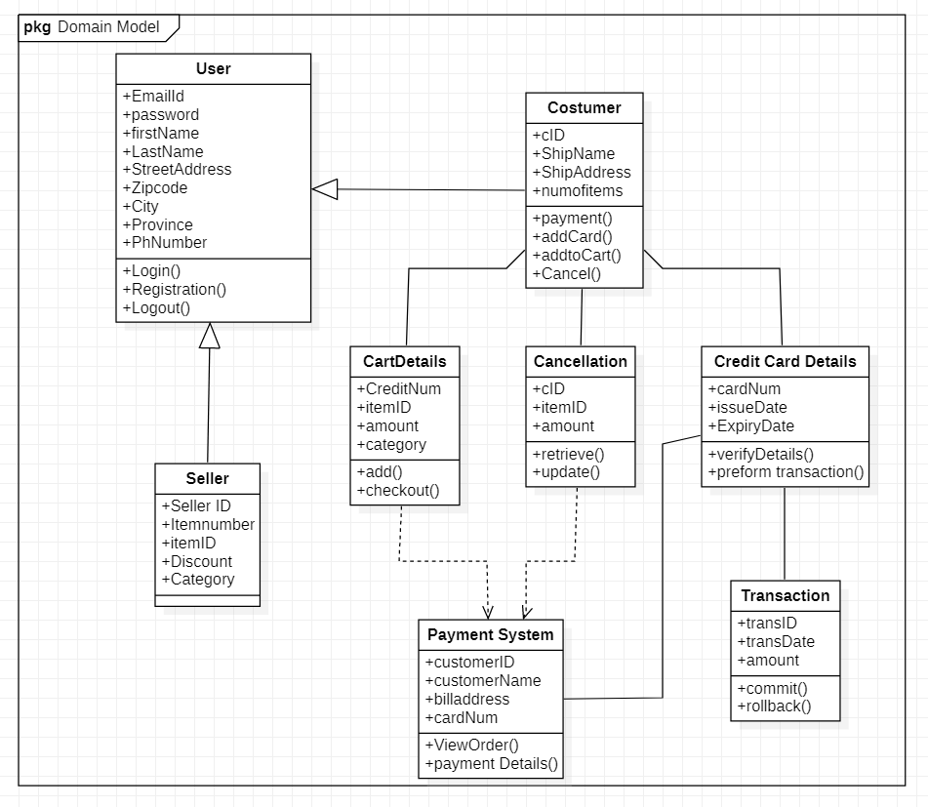

**System sequential diagram:** 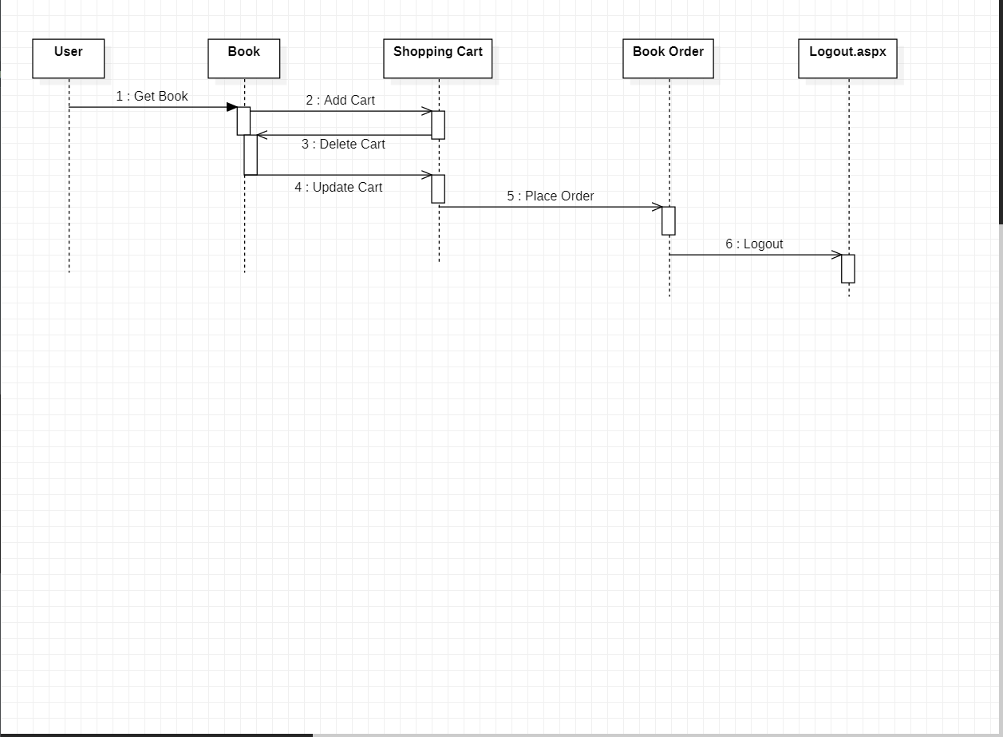

**Operation Contracts:**

|  |  |
| --- | --- |
| **Operation** | add to cart ,remove from cart, buy, validateOrder, |
| **Cross References** | Use Case: shopping cart |
| **Preconditions:** | The buyer selects an item to buy and add it to cart |
| **Postconditions:** | The admin will validate the details of buyer and the payment details, if they are correct the admin will pass the order to seller and the deal will go forward. |